Mathematics Curriculum Progression of Skills Assessment Grids
Note initials of children WB, WT, EXP and GD.

Year 4
Use Assessment Questions from the Ready-to-Progress Criteria Non-Statutory Guidance (DfE, 2020).
Strand | Ready-to-progress Criteria | Working Below | Working towards | EXP | Greater Depth
Number and Place Value (NPV) | 4NPV–1 Know that 10 hundreds are equivalent to 1 thousand, and that 1,000 is 10 times the size of 100; apply this to identify and work out how many 100s there are in other four-digit multiples of 100
 | 4NPV–2 Recognise the place value of each digit in four-digit numbers, and compose and decompose four-digit numbers using standard and non-standard partitioning.
 | 4NPV–3 Reason about the location of any four-digit number in the linear number system, including identifying the previous and next multiple of 1,000 and 100, and rounding to the nearest of each.
 | 4NPV–4 Divide 1,000 into 2, 4, 5 and 10 equal parts, and read scales/number lines marked in multiples of 1,000 with 2, 4, 5 and 10 equal parts.
Number Facts (NF) | 4NF–1 Recall multiplication and division facts up to 12 x 12, and recognise products in multiplication tables as multiples of the corresponding number.
4NF–2 Solve division problems, with two-digit dividends and one-digit divisors, that involve remainders, for example: 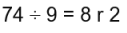
and interpret remainders appropriately according to the context.

4NF–3 Apply place-value knowledge to known additive and multiplicative number facts (scaling facts by 100), for example:
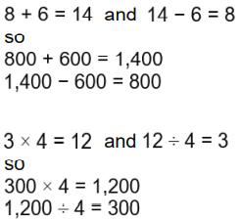

Multiplication and Division (MD) | 4MD–1 Multiply and divide whole numbers by 10 and 100 (keeping to whole number quotients); understand this as equivalent to making a number 10 or 100 times the size.
 | 4MD–2 Manipulate multiplication and division equations, and understand and apply the commutative property of multiplication.
 | 4MD–3 Understand and apply the distributive property of multiplication.
Fractions (F) | 4F–1 Reason about the location of mixed numbers in the linear number system.
 | 4F–2 Convert mixed numbers to improper fractions and vice versa.
4F–3 Add and subtract improper and mixed fractions with the same denominator, including bridging whole numbers, for example:
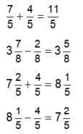
Geometry (G) | 4G–1 Draw polygons, specified by coordinates in the first quadrant, and translate within the first quadrant.
 | 4G–2 Identify regular polygons, including equilateral triangles and squares, as those in which the side-lengths are equal and the angles are equal. Find the perimeter of regular and irregular polygons.
 | 4G–3 Identify line symmetry in 2D shapes presented in different orientations. Reflect shapes in a line of symmetry and complete a symmetric figure or pattern with respect to a specified line of symmetry.

Attitude To Learning | Note initials of children’s attitude to Learning

