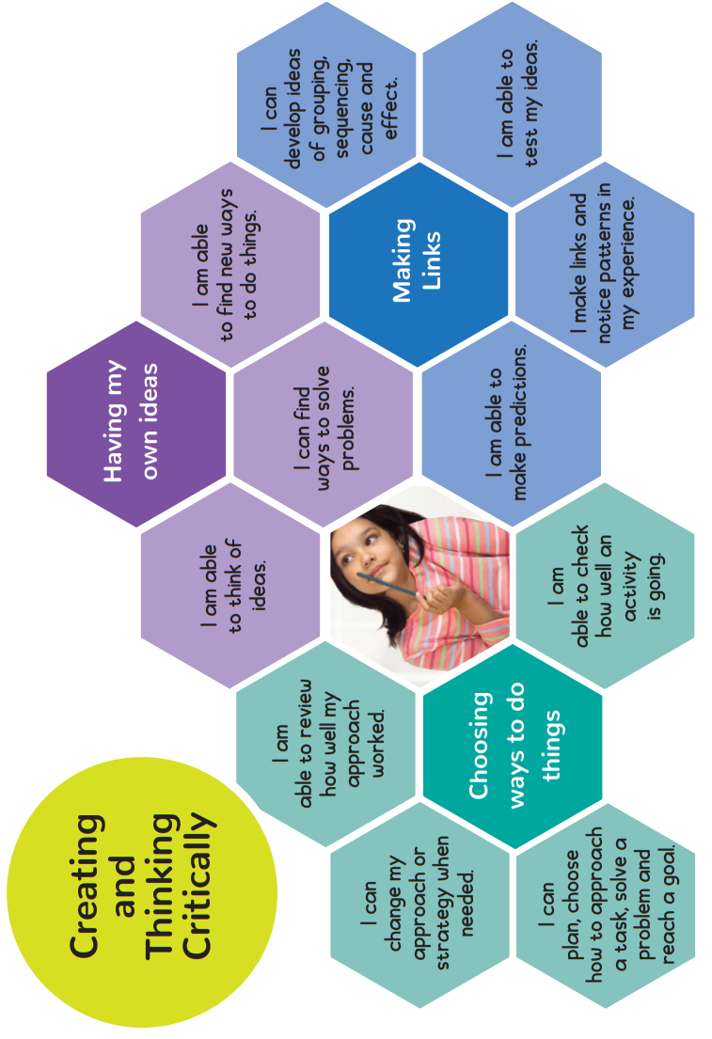




Halwill Primary
Characteristics of Effective Learning – A Parent’s Guide
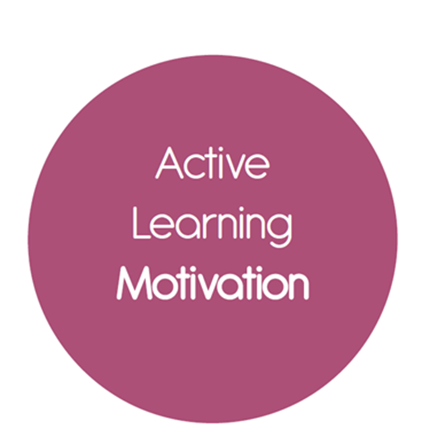
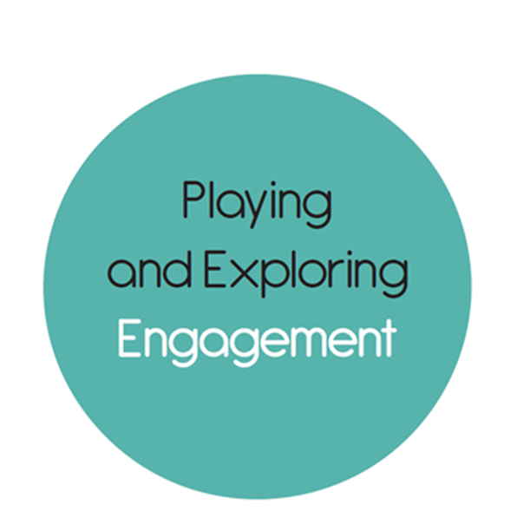


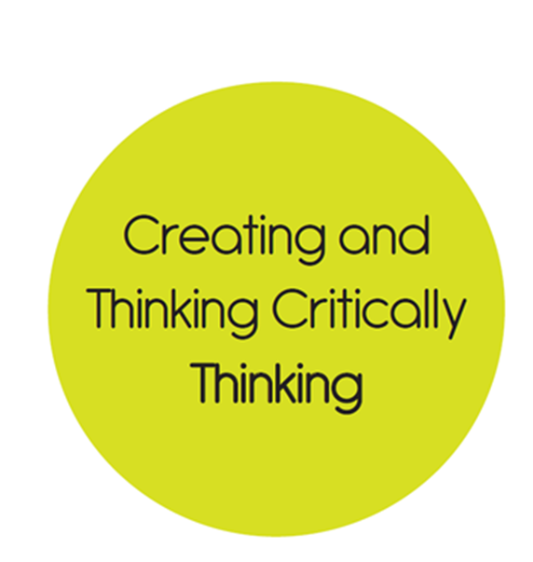
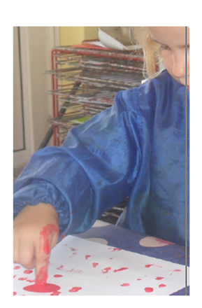

Dear Parents and Carers,

Characteristics of Effective Learning (CoEL)
A child’s individual learning characteristic will determine the way they respond to both the teaching and learning taking place in the environment. Three characteristics of effective teaching and learning identified by the EYFS are:
- playing and exploring - children investigate and experience things, and ‘have a go’;
- active learning - children concentrate and keep on trying if they encounter difficulties, and enjoy achievements; and
- creating and thinking critically - children have and develop their own ideas, make links between ideas, and develop strategies for doing things.
The focus of the CoEL is on how children learn rather than what they learn.
Underpinning the CoEL is the understanding that during their earliest years, children form attitudes about learning that will last a lifetime. Children who receive the right sort of support and encouragement during these years will be creative, and adventurous learners throughout their lives. The environment provided needs to nurture these CoELs without forgetting that children are individuals who bring their own needs, talents and histories.

This term we are focusing on Creating and Thinking Critically and our observations of your child will include a particular focus on this aspect of CoEL. Stickers in their learning journey will also identify particular attributes of the characteristic that we have seen.
How can you help?
On the back of this guide is a
hexagonal image that looks at the
three main areas of Creating and Thinking Critically, namely, ‘Having my own ideas’, ‘Choosing ways to do things’ and concentrating’ and ‘Making Links’ with some statements in child speak to help understanding. For example, help your child to become aware of their own goals by supporting them to solve problems. Describe what you see them trying to do, and encourage children to make predictions and test ideas. Be specific when you praise, especially noting effort, such as how the child concentrates, tries different approaches, persists, solves problems, and has new ideas. Note when your child becomes deeply involved when you provide something that is new and unusual for them to explore.
Can you please use the ‘WOW’ cards to let us know of any observations you have made of Creating and Thinking Critically at home?
It will help us a build a picture of your unique child. Thank you for your support. ☺



